|  |
| --- |
| User Manual  Samuda Inventory |
| REFERENCE: GW/ERP/USER MANUAL |
|  |
| **Genweb2 Ltd.** |
| **11-Apr-18** |



|  |
| --- |
|  |

# Document Information

|  |  |
| --- | --- |
| Document Name | User manual for Inventory |
| Document Author | Rashedul Alam |
| Document Version | 1.0 |
| Release Date | 11th t April, 2018 |

|  |  |
| --- | --- |
| Review by | Md. Matiar Rahman |
| Review Date | 12th April, 2018 |
| Approved By |  |
| Approval Date |  |

# Document History

|  |  |  |  |  |  |
| --- | --- | --- | --- | --- | --- |
| A=Added, M=Modified, D=Delete | | | | | |
| **Version No** | **Date** | **Section No** | **A/M/D** | **Description of Change** | **Author** |
| 1.0 | 11-April-2017 |  | A | Initial | Rashedul Alam |
| 1.1 | 17-April-2017 |  | A | Gate in | Rashedul Alam |
|  |  |  |  |  |  |

Contents

A. Document Information 2

B. Document History 2

1. Introduction 4

1.1 Purpose of User manual 4

2. Configuration by Inventory Manager 4

2.1 Create Indent type by Inventory Manager 4

3. Indents 5

3.1 Indent raise by each employee/Indent Manager 5

4. Indents approval 7

4.1 Indents approval by Indent approver 7

5. Issue Products 8

5.1 Issue Product creation by Inventory user 8

6. Issue PR 10

6.1 Issue PR Creation by Inventory user or Manager 10

6.2 Issue PR Validate by Inventory user or Manager 11

7. Issue PR approval 11

7.1 Issue PR approval by Head of procurement 11

7. Gate in 15

7.1 Create Gate in by Gate in Approver 15

# 1. **Introduction**

The purposes of this User manual is to clearly identify the customer requirements and provide a detailed document. The customer will read this document and get a clear view the sales module. It will also help the review team to validate whether the customer requirements have been fulfilled or not.

## Purpose of User manual

The purpose of this User Manual is to clearly identify the customer requirements and provide a detailed document. The customer will read this document and get a clear view of the Commercial module. It will also help the review team to validate whether the customer requirements have been fulfilled or not.

# 2. Configuration by Inventory Manager

Some configuration require for Inventory module, Admin user can configure this.

## 2.1 Create Indent type by Inventory Manager

Indent type is require for indent creation.

Inventory Manager can create Indent type using the menu **Inventory ‣ Products ‣ Indent type** and click **Create.**

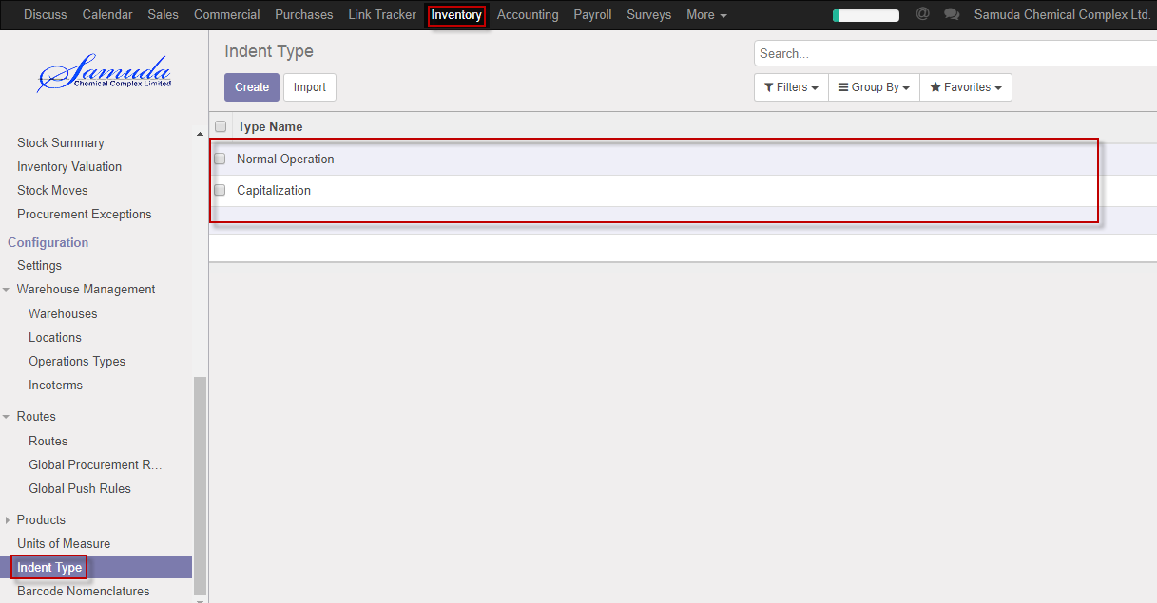

Figure: Indent type List view

We need to set the following:-

**Type name**: Enter a type name.

After entering all information click **Save**.

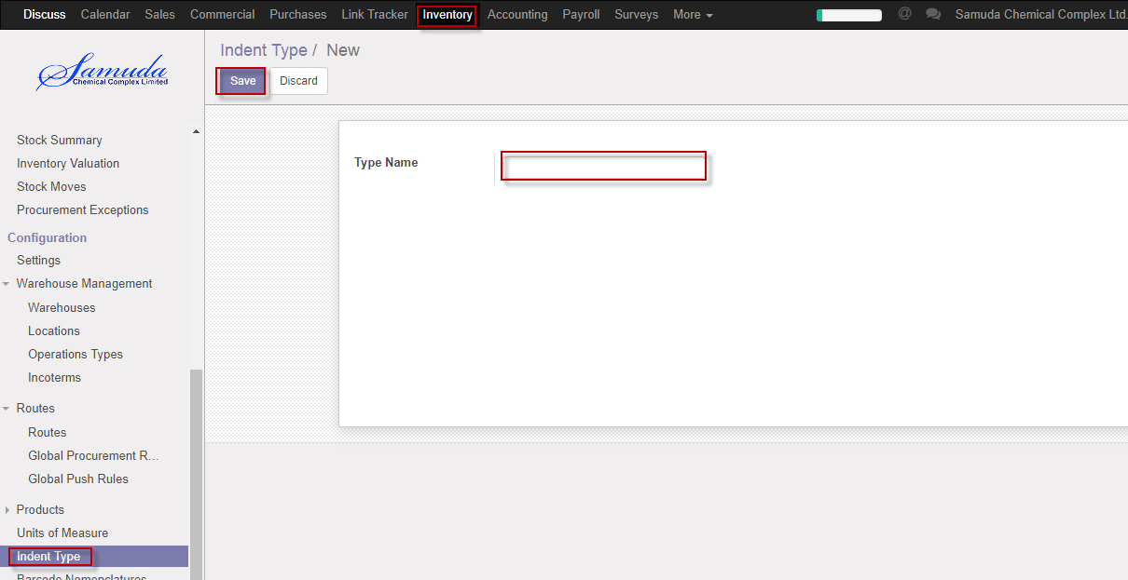

Figure: Create a Indent type

# 3. Indents

Each and every indent user will raise indent and Indent approver will approve indents.

If available stock then indent will go for issue indent and will go done state.

If stock not available then will go for Issue PR and it’s another process.

## 3.1 Indent raise by each employee/Indent Manager

Indent will be created/Edit by each employee/Indent manager

Indent manager/each employee can raise Indent using the menu **Inventory ‣ indents** and click **Create.**

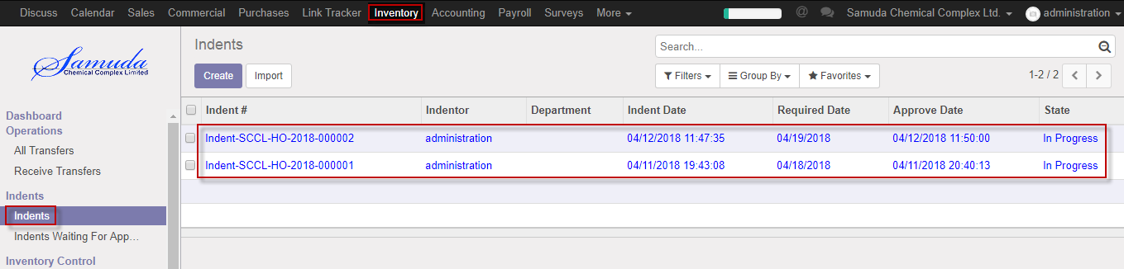

Figure: Indents List view

We need to set the following:-

**Priority**: Select priority.

**Required date:** Select required date.

**Type:** Select type.

**Product:** Select product.

**Quantity:** Select qty.

After entering all information click **Save & Confirm**.

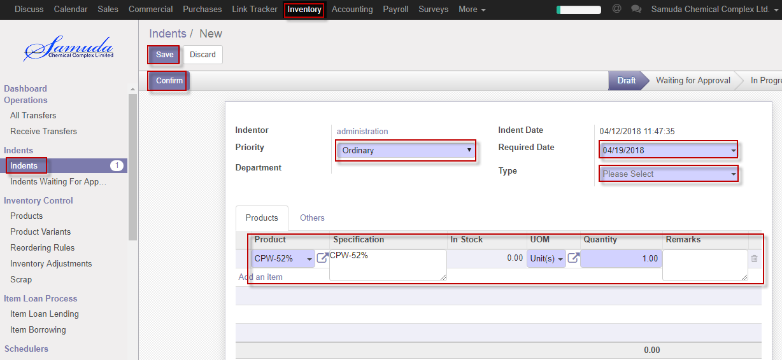

Figure: Create Indents

# 4. Indents approval

Each and every indent user will raise indent and Indent approver will approve indents.

## 4.1 Indents approval by Indent approver

After raise the Indents, Indents approver will get the notification. He/she can update before approve if require.

To see the Pending indents use the menu **Inventory ‣ Indents>>Indents waiting for approval**

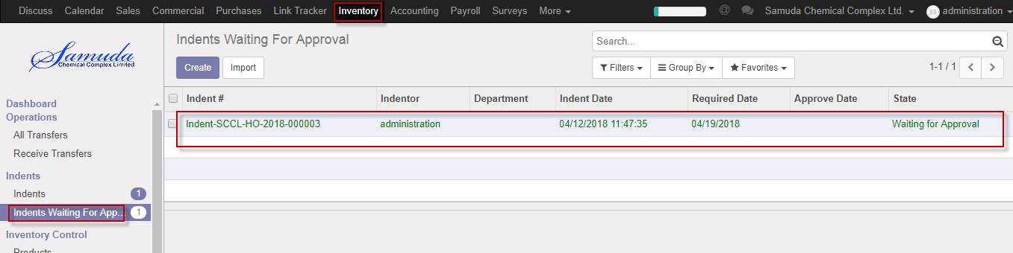

Figure: Indents waiting for approval list view

Indent approver can approve. Select an indent from list then click on **Approve** button 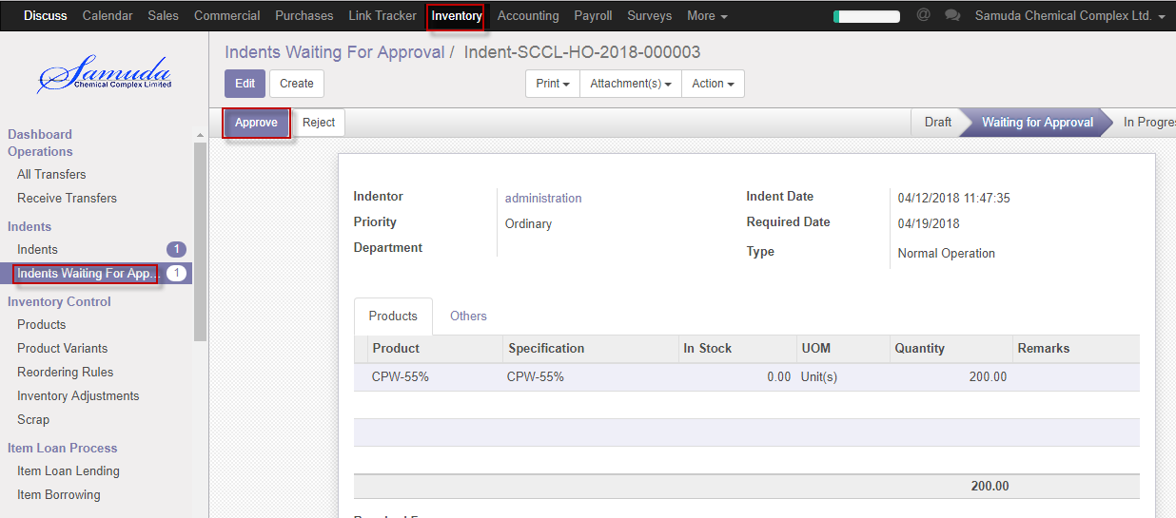

Figure: Indents approved

Indents approver is capable to reject indent by click **Reject** Button.

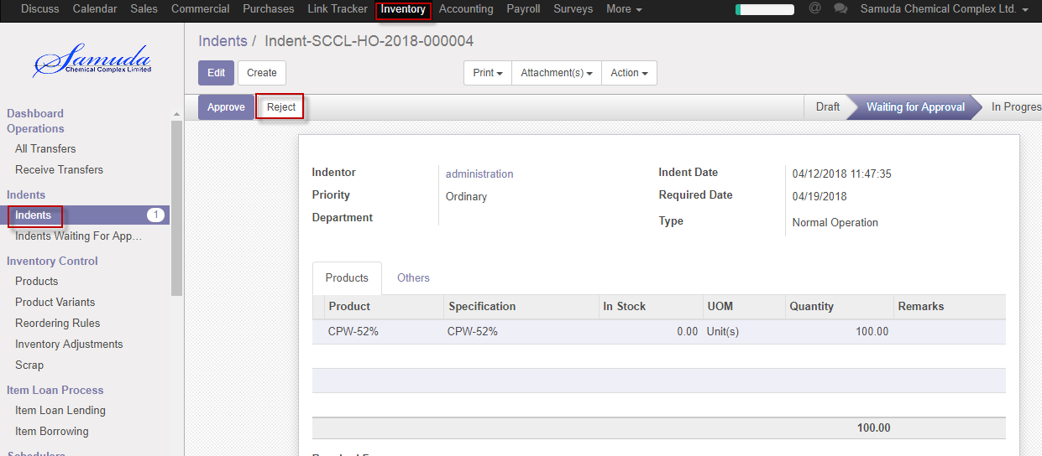

Figure: Indents reject

# 5. Issue Products

If product is available in stock then will go for issue product. Inventory user will create issue product.

## 5.1 Issue Product creation by Inventory user

Issue Products will be created/Edit by Inventory user.

Inventory user can create Issue Product using the menu **Inventory ‣ indents** >>**Issue Product>>** click **Issue product** Button**.**

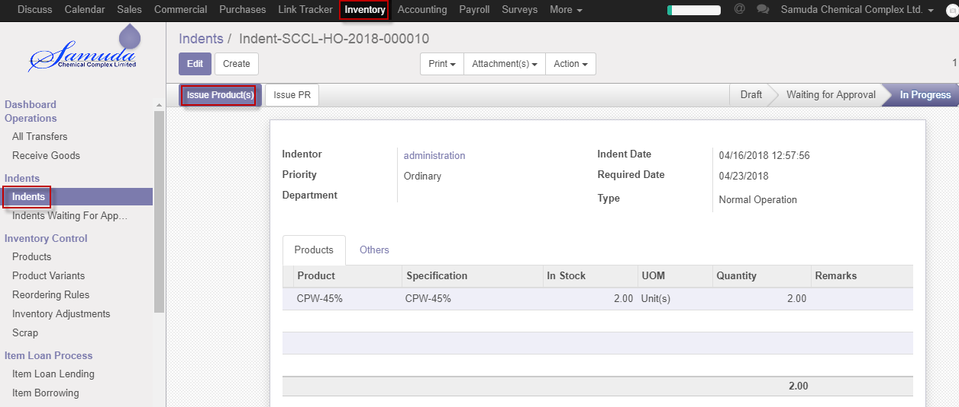

Figure: Create Issue Product

Mark as Todo by click **Mark as Todo** Button. Mark as TOdo by Inventory user.

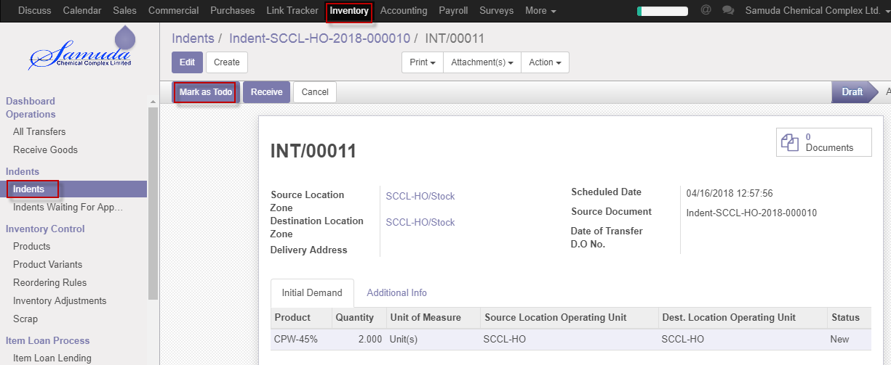

Figure: Issue Product Mark as doto

After click Mark as Todo button will open Reserve window then Click Reservebutton

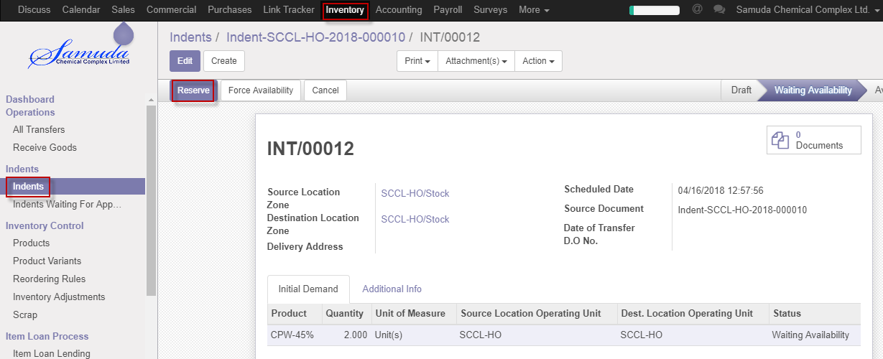

Figure: Reserve creation

After click Reserve button will open Receive window then Click **Receive** buttonthen finally issue product will go for done state.

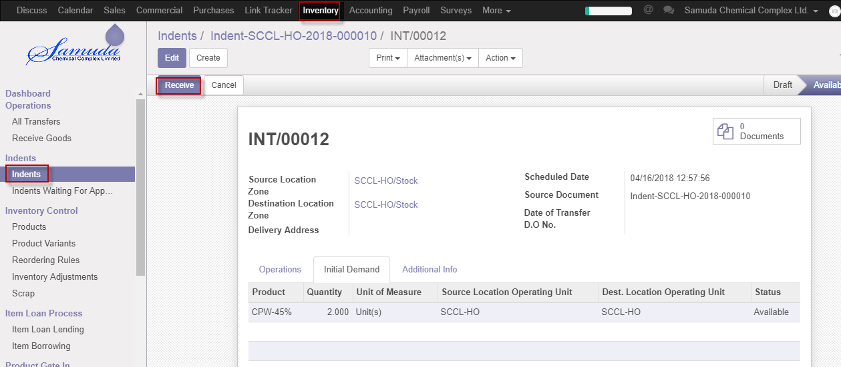

Figure: Received

# 6. Issue PR

## 6.1 Issue PR Creation by Inventory user or Manager

Issue PR will be created/Edit by Inventory user/Manager.

Inventory manager/user can create Issue PR using the menu **Inventory ‣ indents** >>**Issue PR and click & Confirm.**

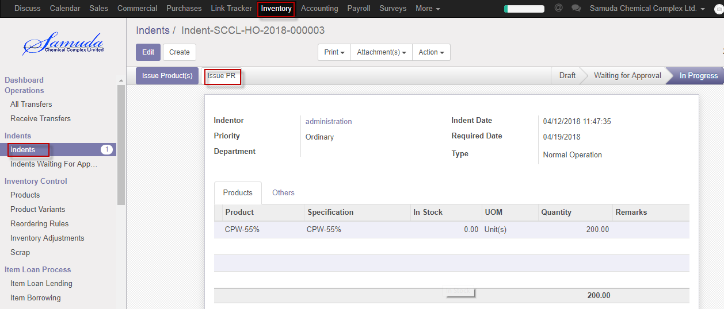

Figure: Issue PR Creation

## 6.2 Issue PR Validate by Inventory user or Manager

Validate Issue PR by click **Validate** Button. Validate by Plant in charge.

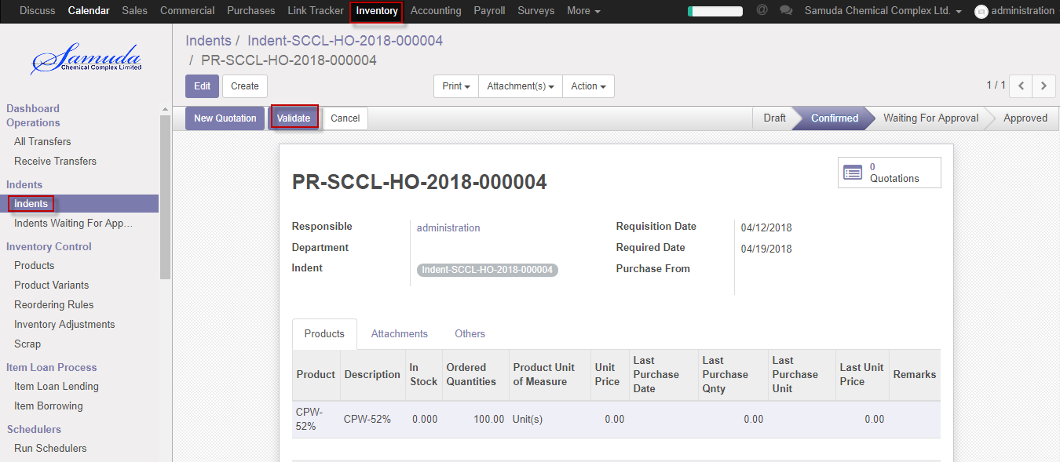

Figure: Issue PR validate

After click Validate button will open following window then Select purchase from & **Save**

If select own then will go for Issue IoU and select HO then will go for HO procurement for Final approve**.**

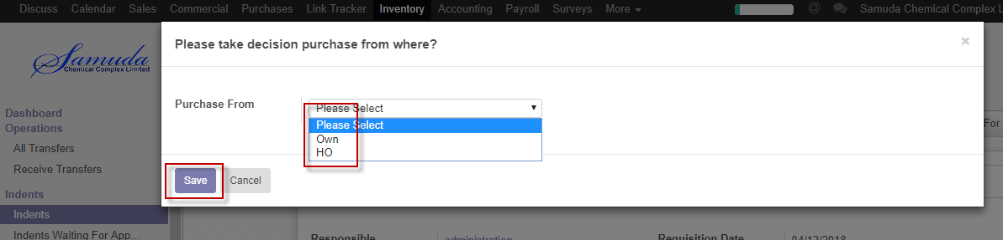

Figure: Create Indents

# 7. Issue PR approval

## 7.1 Issue PR approval by Head of procurement

After Validate the Issue PR Head of Procurement will get the notification. He/she can approve to see use the menu **Inventory ‣ Indents>>Click Approve**

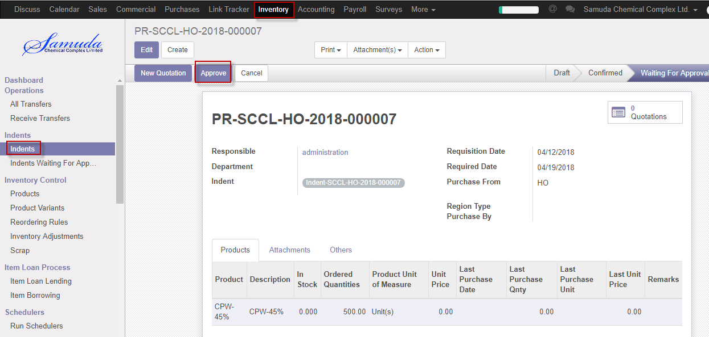

Figure: Indents waiting for approval list view

Following window will open after click **Approve** button then select region type & Purchase by

Select region type Local or Foreign and also will select Purchase by which method Cash,Credit,LC or TT.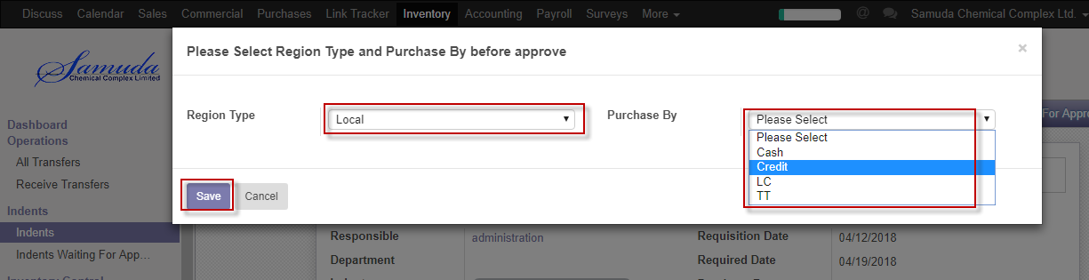

Figure: Purchase method

Following window will open after click **save** button then will ready for New Quotation .New quotation Approve by Head of procurement.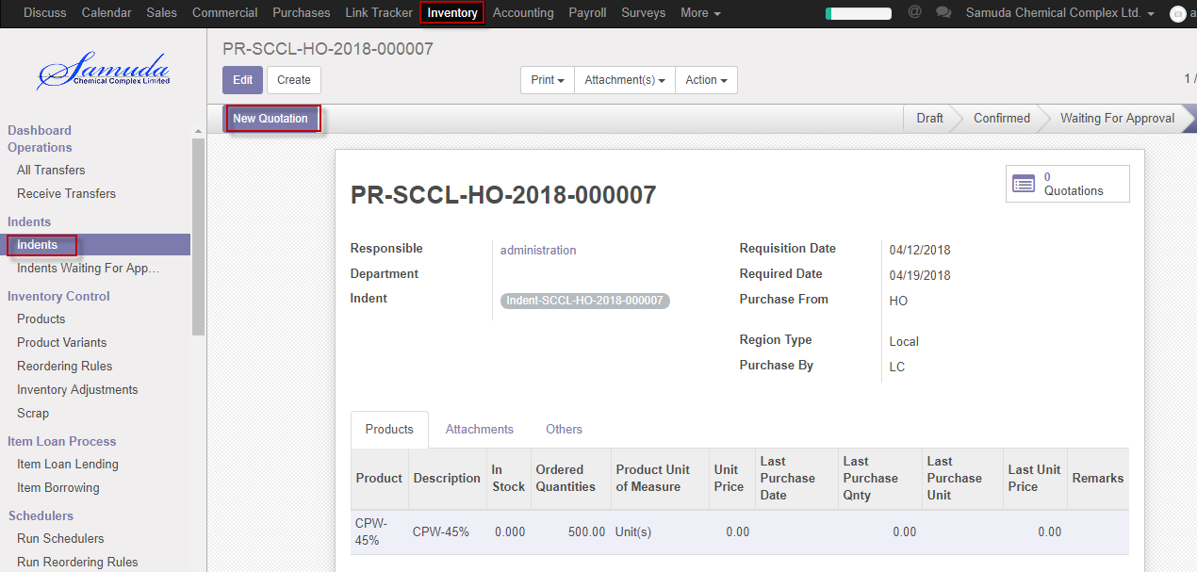

Figure: Create new quotation

Click New quotation button & Select supplier after select all info will come auto and head of procurement is capable to edit then Click **Confirm order** button. Confirmed By Head of Procurement.

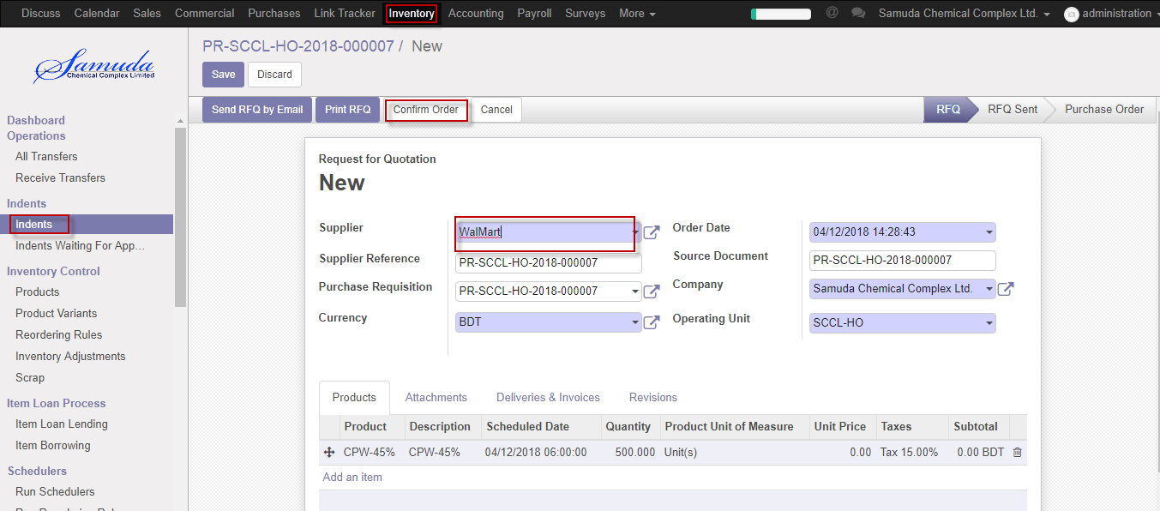

Figure: Confirm order

Following window will open after click Confirm order Button then select region type & purchase by then save then Click Purchase order button then finally Issue PR will approve.

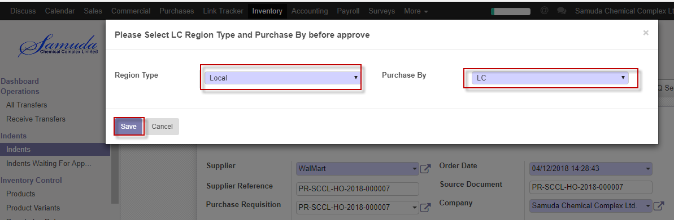

Figure: Purchase method

Following window will open after click Save Button then Click Approve order button then finally Issue PR will approve.

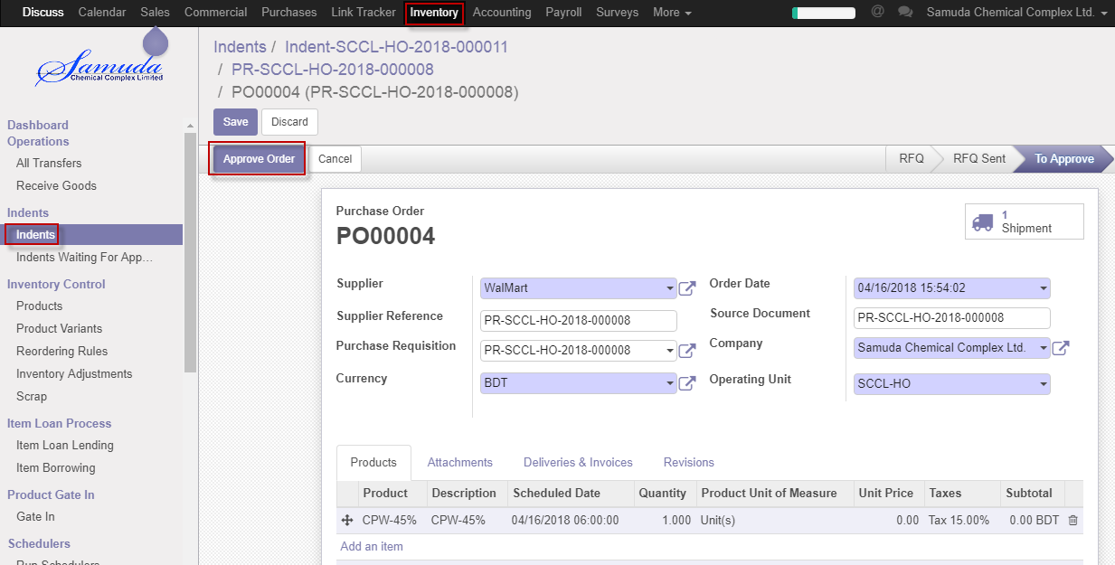

Figure: Approve PR

# 7. Gate in

## 7.1 Create Gate in by Gate in Approver

Gate in will be created/Edit by Gate in approver

Gate in Approver can create Gate in using the menu **Inventory ‣ Product Gate in>>Gate in** and click **Create.**

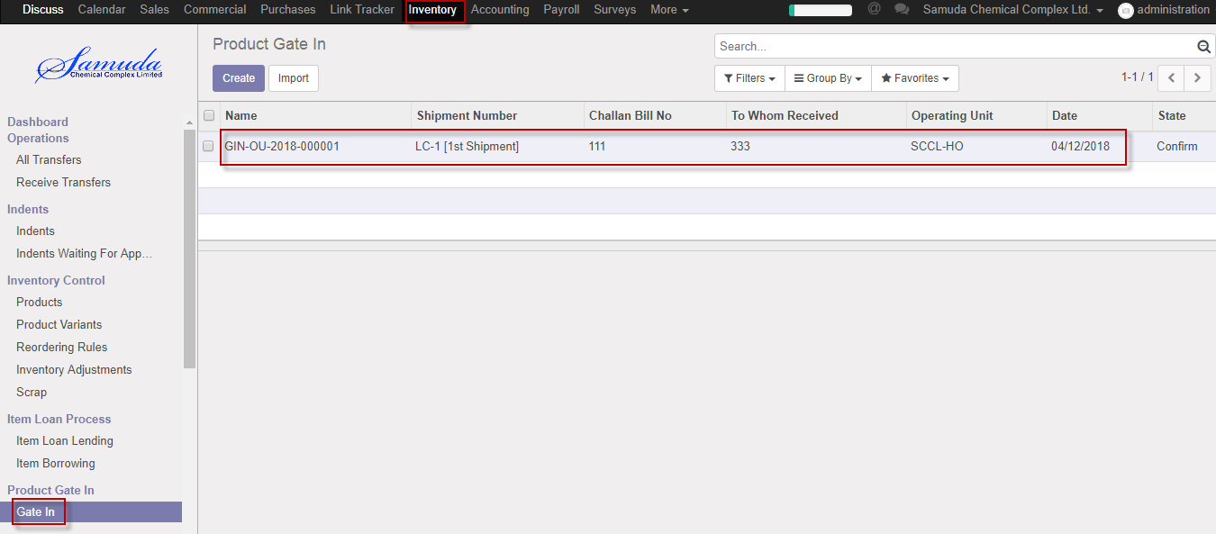

Figure: Gate in List view

We need to set the following:-

**Receive type**: Select receive type.

**Date:** Select date.

**Challan bill no:** Enter challan bill no.

**Track/Vehicle no:** Enter Track/Vehicle no.

**Shipment No:** Select Shipment no.

**Carried By:** Enter carried by.

**To whom received:** Enter to whom received

After entering all information click **Save & Confirm**.

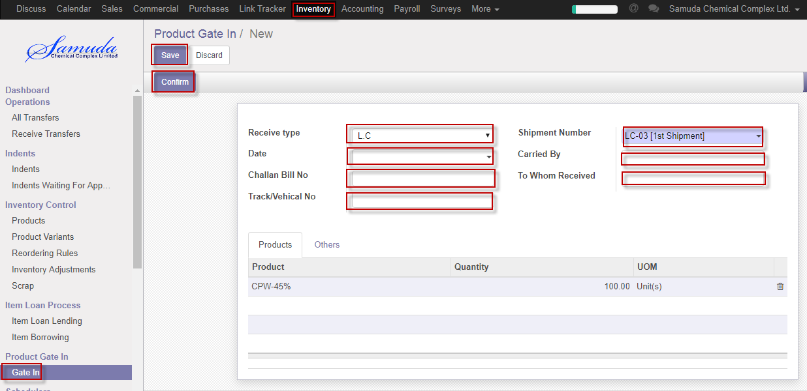

Figure: Create Gate in